Changemakers: Global Leadership Institute
Launch Year Application
Eliot Summer Academy: Mary Institute and Saint Louis Country Day School
We are thrilled that you are interested in representing your community as a participant in the Changemakers: Global Leadership Institute. Please take the time to carefully read the information we have provided on our website prior to completing the application.
What you should know:
Eligibility
Open to current rising 9th-12th grade Saint Louis youth

Program fees

- Program cost: $250
- Acceptance into the program will be finalized once program fees are paid. Payment deadline is June 15.

Application process

- Applications will be accepted and reviewed on a rolling basis until June 15.
- Please email completed applications and letters of recommendation to eliotacademy@micds.org
- Upon acceptance into the program, please enroll in the Institute online at https://www.micds.org/summer-adventure/eliot-summer-academy/

(If a student is not accepted to the institute this year, we encourage you to reapply for the subsequent year. A second application demonstrates determination, resilience and commitment to the program making you stand out as a candidate).
Applicant information:
Name: ______________________________________________________ Current Grade level: _________________
Guardian’s Name(s): __________________________________________________________________________
Guardian e-mail(s): ____________________________________________________________________________
Student e-mail(s): ____________________________________________________________________________
School: _________________________________________________________________________________________
Student address: _______________________________________________________________________________________
Student telephone number:______________________________________________________________________
Emergency contact name/number: ___________________________________________________________________
If your school has agreed to financially sponsor you, please have an authorized school official sign here and contact us at eliotacademy@micds.org _________________________________________________________________________________________________________
Student questions
Please answer each of the following questions with a thoughtful paragraph.
- Please list two (2) characteristics you would like to share that distinguish you as a unique individual that will contribute to this diverse community endeavor.

- Why are you most interested in participating in the institute? What do you think you would gain the most from participating in this program?

- Why are the voices and actions of local youth imperative in addressing challenges and issues faced in our Saint Louis and global communities?

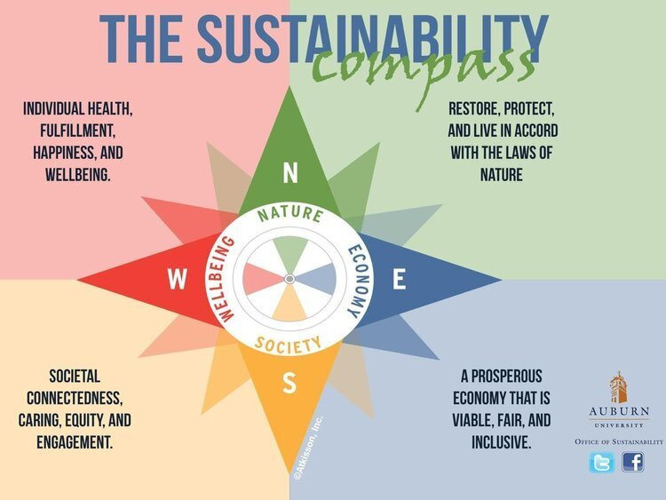
- Tell us briefly about two (2) issues that are important to you and why (this will not limit the direction you go with the institute)?
(You may use the images to help guide your response)

5. How do you see yourself as a positive representative for your school, neighborhood and/or the Saint Louis community as a young global leader?

Teacher Recommendation – to be filled out by a teacher who can speak of the applicant’s character and suitability for participation in this institute.

Student Name _____________________________________________________________________________________
Educator Name/Role___________________________________________________________________________________________
We ask teachers to be as honest as they can about the student and then to return this to Ms. Emily Coppersmith at eliotacademy@micds.org

 | No basis for  judgment | Below average | Average | Good | Excellent | Outstanding
Outward interest in service to the community
Academic Self-Discipline
Personal Initiative
Leadership
Self-confidence
Openness to new ideas
Comfort with interacting with peers
Comfort with interacting with adults
Outward interest in service
Outward interest in global and/or community issues

2. Please state briefly why you think this student is a good candidate for the Changemakers Institute. If not, please explain why.

Logistics and Parent Signatures

I am aware of what attending the Changemakers: Global Leadership Institute would entail for my child.
_______________________________________________________________________________________________________
I am aware that the sustainable nature of this experience means that it extends beyond the summer experience and I support my child’s desire for continued action and participation in monthly meetings (via online or in-person).
______________________________________________________________________________________________________________

Student signatures:
I am aware of what attending this program would entail and look forward to participating fully if I am selected ______________________________________________________
I am committed to continued participation in the community. Meaning, I am aware that though my areas of action may evolve throughout the year, I will be working in some capacity to continue doing throughout the school year what I began during the summer ________________________________________________________________________________________

